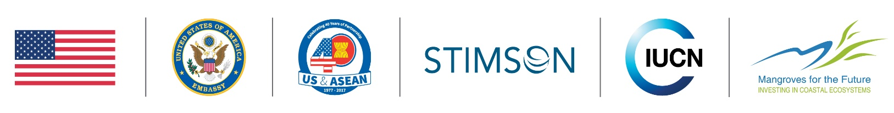

Media is cordially invited to cover

WHAT: U.S.-ASEAN Conference on Marine Environment Issues

WHEN: 14-15 September 2017, 09:00-17:00
Shangri-La Hotel, Bangkok

The state of marine conservation in Asia

The U.S.-ASEAN Conference on Marine Environmental Issues is one of the most important marine conservation events in the region.

Building on numerous inaugural commitments announced at the Our Oceans Conference 2016 and the recent United Nations Ocean Conference, the event will provide key stakeholders with the opportunity to explore and recommend policies that will contribute to improved governance of marine and coastal resources. The conference will serve as a model to showcase and develop regional collaborative efforts, policies and technical work which can support Sustainable Development Goal 14 “Conserve and sustainably use the oceans, seas and marine resources” implementation and preparation for the Our Oceans Conference 2018 in Indonesia.

The U.S.-ASEAN Conference on Marine Environmental Issues brings together over 50 marine experts from think tanks, academia, the private sector, nongovernmental organisations and governments across ASEAN member countries, as well as the United States, India, Japan and Australia.

The Stimson Center, on behalf of the U.S. State Department and in collaboration with IUCN and the Mangroves for the Future (MFF) Programme, is co-chairing the conference.

Schedule
Most of the conference’s sessions (not listed below) will be held under the Chatham House Rule.
The media is invited to attend the sessions below that will not be held under the Chatham House Rule:

14 Sep | 08:00-09:00 | Registration
 | 09:00-10:15 | Opening Plenary: Leaders Forum
 | 10:30-12:00 | Topic Plenary 1: Combatting Illegal, Unreported, and Unregulated Fishing
15 Sep | 09:00-10:15 | Topic Plenary 2: The Blue Economy

Who will be there*
- Minister Kobkarn Suriyasat Wattanavrangkul (Thai Minister for Tourism and Sports); video address from Minister Susi Pudjiastuti (Indonesian Minister for Maritime Affairs and Fisheries),
- Government representatives, as well as delegates from environmental NGOs and educational institutions
- Private sector representatives
*There might be interview opportunities with these representatives

FOR CONFIRMATIONS OR MORE INFORMATION PLEASE CONTACT:
Ann Moey, Head of Communications, IUCN Asia
+66 92 259 8035, ann.moey@iucn.org

Visit https://www.iucn.org/regions/asia/our-work/coastal-and-marine-ecosystems/us-asean-conference-marine-environmental-issues for details

About IUCN
IUCN is the world’s oldest and largest global environmental organisation, with more than 1,200 government and NGO Members and almost 15,000 volunteer experts in some 160 countries. IUCN helps the world find pragmatic solutions to our most pressing environment and development challenges. It supports scientific research, manages field projects all over the world, and brings governments, NGOs, the UN and companies together to develop policy, laws and best practice. IUCN’s Asia Regional Office is in Bangkok, Thailand, with country, programme and liaison offices in Bangladesh, Cambodia, China, India, Lao PDR, Nepal, Pakistan, Sri Lanka, Thailand and Viet Nam.

Website www.iucn.org/asia | Facebook www.facebook.com/iucn.asia | Twitter @IUCNAsia

About Stimson
The Stimson Center is a nonpartisan policy research center based in Washington, D.C. working to solve the world’s greatest threats to security and prosperity. The Stimson Center’s Environmental Security Program explores the threat of illegal, unreported and unregulated (IUU) fishing, and its attendant crimes, to U.S. national and regional security, as well as the impact of distant water fishing (DWF) fleets on local communities. The Stimson Center’s Southeast Asia program addresses non-traditional security threats facing ASEAN countries and places special emphasis on issues related to water and energy in the Mekong Basin.

Website www.stimson.org | Facebook www.facebook.com/stimsoncenter | Twitter @StimsonCenter

