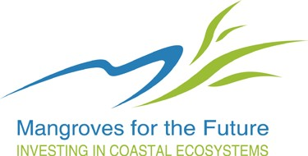

Mangroves for the Future
Reporting Templates for Grant Facilities

Effective date: 01 July 2013

Document Version: 15 October 2013

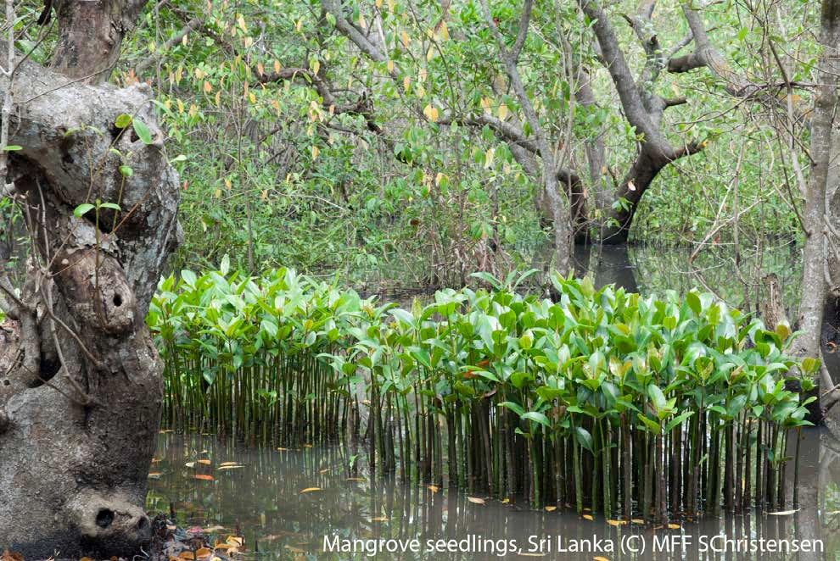

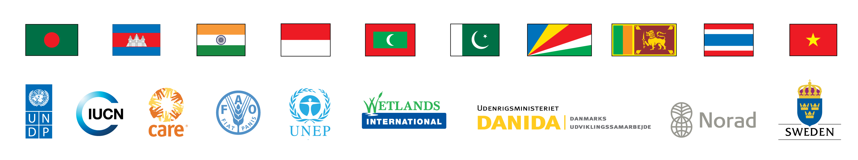

Reporting Templates for Grant Facilities

Template 1. Progress Report for Small Grant Facility

Template 2. Financial Progress Report for Small Grant Facility

Template 3. Final Report for Small Grant Facility
Template 4. Inception Report for Medium Grant Facility
Template 5. Progress Report for Medium Grant Facility
Template 6. Financial Report for Medium Grant Facility

Template 7. Final Report Template for Medium Grant Facility

Template1:
Progress Report for Small Grant Facility

Title of Small Grant Facility Project

- Project Details

Project number
Project duration
Total project cost
Budget provided by MFF
Name of Organization
Period of Reporting & Date of report submission
Report Submitted by

- Progress of activities

Objective:
Result/Output | Accomplishments during the period of reporting
 | Remark: Include any information relevant for this section

- Major relevant changes in the work plan

- Issues and constraints on project implementation

- Changes brought about by the project

- Is the project creating opportunities for participation of both men and women? How?

- Activities that communicate project results
Objective | Activity | Target Audience | Date Completed | Products | Person Responsible

- Lessons Learned. What were the best ways to achieve the project results? What can be done to better achieve project results? What should be avoided? Record both positive (what worked best) and negative (what did not work) experiences.

- Photos that illustrate project activities.

Pointers:
- Provide a caption for the image
- Identify the photo credit: what is the name of the person or organisation to be acknowledged for the image?
- Submit a copy of the image separately as a JPEG file. Name the image in this format:
  - Title of activity in the photo-location-country (c) MFF-Photo credit-Year taken
for example
Aloe vera plantation managed by beneficiary-Puttalam-SriLanka(c)MFF-KEkaratne-2013

Template 2.
Financial Progress Report for Small Grant Facility

Grantee's Name
Project Name
Project Number
Reporting Period
Currency
Description | Approved Budget (A) | Reference to supporting documents | Expenditure |  |  |  | Total Expenditure  (B) | Balance  (A-B)
Description | Approved Budget (A) | Reference to supporting documents | Q-1 | Q-2 | Q-3 | Q-4 | Total Expenditure  (B) | Balance  (A-B)
PREPARATORY WORK
PROJECT ACTIVITIES
PROJECT MANAGEMENT
Summary
Total Expenditure
Less
Funds Received from IUCN
Balance

Template 3.
Final Report for Small Grant Facility

Notes:
- Suggested length of the Report – About 10 – 15 pages; Additional information may be provided as Annexes.
- The report should take into account all the outputs, outcomes and impacts for the entire project period.

- Project Profile

Project Title:
Project Number:
Project duration: | Start date
Project duration: | Original End date
Project duration: | Final End date
Project Budget: | MFF Contribution | Counterpart funds
Project Budget: | USD XX,XXX | USD XX,XXX
Name of Organization:
Contact Details: (Including telephone/ email)
Report Submitted by: (name and position)
Date of Report Submission:

- Executive Summary (max 2 pages)
- Background of the Project and Project Rationale
Not more than one page: Summarize the context and the problem in your project area, and why the project was necessary.
- Activities completed:
Outline the activities completed. Were there any changes in the planned activities and the actual activities? If yes, please explain. Was it necessary to undertake any activities that were not planned?
Explain if there were any major delays and the reasons for such delays.
- Achievement of Objectives and Results (=Outputs)
Using the Project’s logframe and Indicators, provide an assessment of the achievement of Objectives and Results as well as Outcomes and Impacts. Please elaborate on:
- Were the project’s stated objectives and outputs achieved, not achieved or partially achieved? In the event of partial or non achievement, please explain the reasons.
- The extent to which the achievement of outputs and objectives have contributed to meeting the overall Goal of the project (long-term effects).
- Unforeseen challenges and opportunities, if any and how they were addressed.
- Reflect on the logical links between Objective(s), Results and Activities (carrying out the planned activities may not always lead to achieving the stated outputs and achieving the outputs does not guarantee that the objectives are met).
Also include a statement of achievement of deliverables as against the logframe/contract.
- Interesting stories (1-2):
Each story should tell a story!! Set the scene (where, location, who), describe what happened, and then say what was learned from the story and the conclusions so far.
The story should be “alive”, interesting and catchy. It should involve real people (community X did such-and-such; Mrs. Y learnt this and is now harvesting that; as a result the family income has increased by Z%) or it should demonstrate other sorts of lessons
- Knowledge products produced
Please provide a table of Publications, posters, brochures, photos, videos, etc. in the format below:
Description of the Knowledge Product [citation, no. of copies, publisher/producer etc.] | How was this product used?

- Major constraints and challenges
Please mention if there were any constraints and challenges in completing activities. Also mention if there were any positive or negative changes in circumstances that affected the activities or results/outcomes (example: political in/stability, natural, presence of other organizations doing similar works that you had not foreseen etc.)
- Lessons learnt:
Please outline the lessons learnt from this project. The lessons learnt should reflect both technical lessons and the management lessons. If you were to do this project again, what would you improve?
- Policy recommendations, if any.
Provide recommendations, if any, for policy development.
- Final financial report (same as the template in progress report template)
Report expenses based on approved budget and what has been expended against individual budget lines/categories.

- ANNEXES (optional)
- Any material that you want to share and does not fit in the main body
- It is not mandatory to have annexes!

MFF Secretariat Bangkok, version 28 August 2012

Template 4.
Inception Report for Medium Grant Facility

Upon signing the contract for MFF Medium Projects, the Grantees are required to provide the MFF Secretariat an INCEPTION REPORT, usually within 30 days of commencement of the project (INCEPTION PERIOD). The Inception period provides an opportunity to revisit the project proposal (probably written some months before approval) with a view to develop a clear definition of the project and details of intended Results and Outputs. During this time, it is also possible to collect preliminary data to be used in redefining the project’s work programme.

At the end of the Inception period, an INCEPTION WORKSHOP is held with the participation of all stakeholders, project’s implementation/collaborating partners and other interested parties. The Inception Workshop has several key features, as follows:
- Formal announcement and the launch of the project to all parties;
- Provide an overview of the situation analysis, why the project was necessary, project’s Objectives, Results and Indicators and Outcomes (review the logframe as well);
- Formalise project implementation modalities including project steering and monitoring mechanisms, support of other governmental and non-governmental agencies, field work, project staffing and assigning roles and responsibilities to all involved in the project;
- Address project’s risks and develop a mitigation plan;
- Develop the project’s work-plan and a detailed work-plan for the first six months, and agree on deliverables;
- Agree and document monitoring, learning and evaluation protocols including Indicators;
- Develop a detailed budget and cash-flow scenario for the short-term;

Following the Inception Workshop, an Inception Report should be prepared, and a suggested Table of Contents is as follows:
  - An introduction to the Project, its Objectives, Results, Outputs and the current status of information pertaining to the project (about 2 pages)(the agreed logframe should be an Annex as well as the proposal, if it has been revised);

  - Description of the project site(s) (about 1 page) (provide maps, if relevant, as an Annex);

  - Stakeholders and Partners (1 – 1.5 pages);

  - Implementation Arrangements with a commentary on the following (about 5 pages):
    - Project Management arrangements, staffing and their roles and responsibilities;
    - Project steering and monitoring mechanisms;
    - Formalisation of arrangements with the implementing/collaborating partners and linkages to the Government authorities and non-governmental agencies;

  - Summary of studies done so far (baseline data collection etc.) and the expectations of the stakeholders (about 2 pages);

  - Description of methodologies including data collection, field studies, and tools (examples could include informal and formal surveys, direct and participatory observations, community interviews, focus groups, expert opinion, case studies, and literature search) (about 2 – 3 pages);

  - Description of project’s risks and key issues and the mitigation plan to address those (1 page);

  - Project’s updated work-plan including a detailed work-plan for the first six months (the detailed work-plan should identify key activities per outputs, and tasks per activities, including those responsible) (3-4 pages)

  - Budget and financial disbursement arrangements(2-3 pages);;

  - Monitoring, Learning and Evaluation (1 page);

  - Reporting (responsibilities of various entities in reporting and frequency) (0.5 – 1 page);

  - A summary of the decisions arrived at the Inception Workshop (1 page) (if there is a separate report of the Inception Workshop, please attach that as an Annex);

  - A section on any other matter germane to the implementation of the project (1 page)

MFF Secretariat, IUCN Asia Regional Office, Bangkok
ver 10 October, 2011

Template 5.
Progress Report for Medium Grant Facility

- Project Details

Project title:
Grantee & Address:
Project Start Date:
Project End Date:
Reporting Period:
Date Submitted:
Financial Disbursement details
MFF Grant amount | USD
MFF Funds received | USD
MFF Funds spent to date | USD
MFF Funds available balance | USD
MFF Grant amount requested | USD
Counterpart funds committed by Grantee | USD
Counterpart funds expended by Grantee | USD

- Executive summary (250 words maximum)
- Detailed implementation summary of progress with reference to the project logical framework and work-plan for the reporting period (A summary should be presented in Annex 1)
- Progress towards Outcomes, if any
- Review of original assumptions/risks, time-lines and work-plan with a commentary on any delays on implementation (and any anticipated delays)
- Cross-cutting themes (climate change; gender; communications)
- Monitoring, Evaluation and Learning undertaken during the reporting period
- Project management aspects
- Financial report (Annex 2 would be the detailed statement)
- Implementation plan for the next six months
- Any other matters
Report submitted by:

Name:
Title:
Signature:
Date:

MFF Secretariat, Bangkok
ver 20 November 2011

Template 6.
Financial Report for Medium Grant Facility

(Excel File Provided in a separate file)

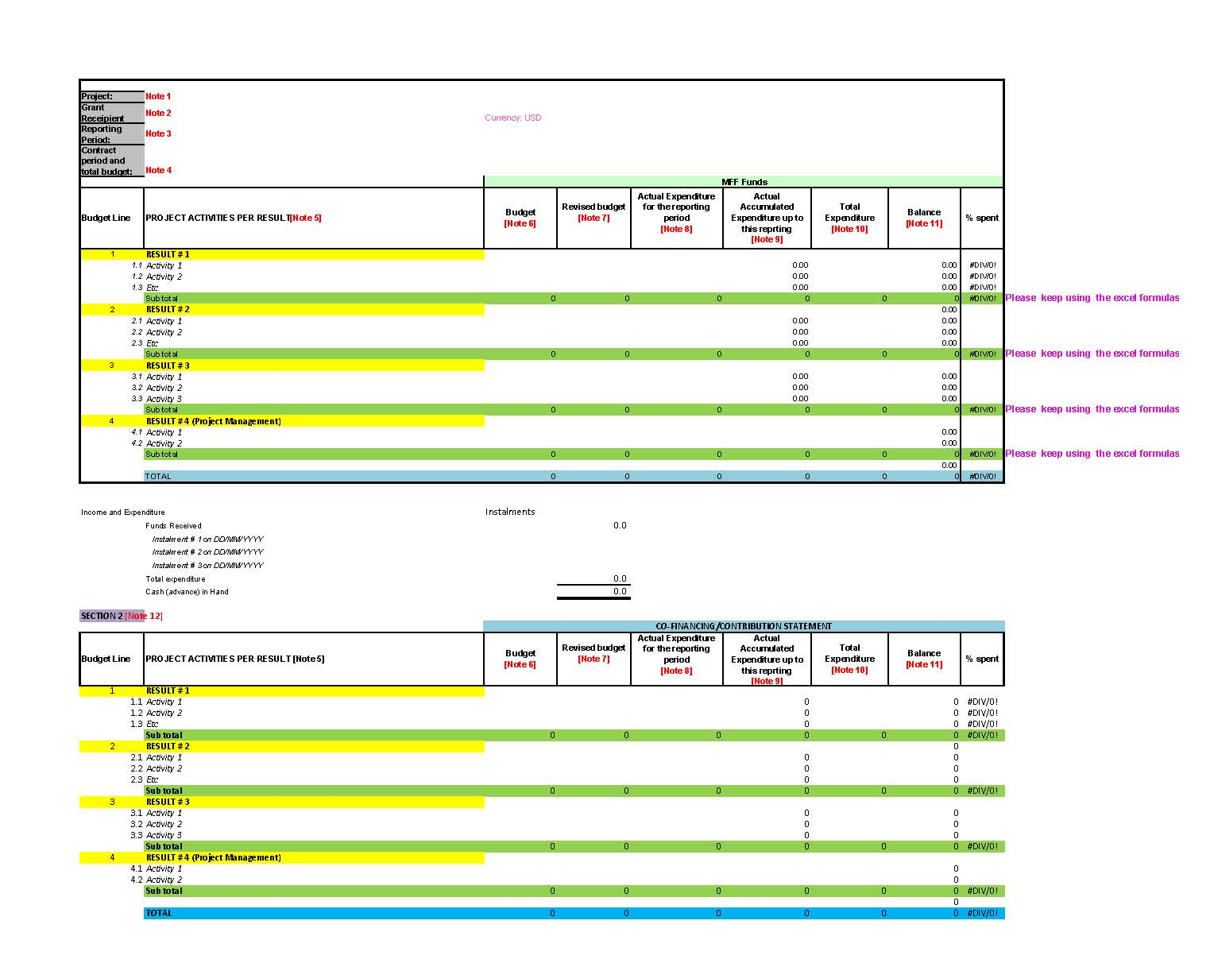

Template 7.
Final Report Template for Medium Grant Facility

- Project Profile

Project Title:
Project Location
Project Number:
Project duration: | Start date
Project duration: | Original End date
Project duration: | Final End date
Project Budget: | MFF Contribution | Counterpart funds
Project Budget: | USD XX,XXX | USD XX,XXX
Name of Organization:
Contact Details: (Including tel/ email)
Report Submitted by: (name and position)
Implementing Partners
Date of Report Submission:

- Executive Summary (max 4 pages)
- Background of the Project and Project Rationale (about 2 pages)
- Give a brief physical and social context of the project area. What were the conditions of the ecosystem or people dependent on it? Who are the beneficiaries? Where was the project carried out [provide a map showing the location(s) of the project].
- What was the problem to be addressed? Provide the rationale for the project.
- What were the expected contributions to MFF’s PoWs?
- Provide the Project’s most up-to-date logframe (as an Annex).
- Activities completed:
Outline the activities completed. Were there any changes in the planned activities and the actual activities? If yes, please explain. Was it necessary to undertake any activities that were not planned?
Explain if there were any major delays and the reasons for such delays.
Provide a narrative on the Beneficiaries.
Provide a narrative on Implementing Partners and their roles and responsibilities.

- Achievement of Objectives and Results (=Outputs)
Using the Project’s logframe and Indicators, provide an assessment of the achievement of Objectives and Results as well as Outcomes and Impacts. Please elaborate on:
- Were the project’s stated objectives and outputs achieved, not achieved or partially achieved? In the event of partial or non achievement, please explain the reasons.
- The extent to which the achievement of outputs and objectives have contributed to meeting the overall Goal of the project (long-term effects). Provide a narrative on the Outcomes and Impacts of the Project.
- Unforeseen challenges and opportunities, if any and how they were addressed.
- Reflect on the logical links between Objective(s), Results and Activities (carrying out the planned activities may not always lead to achieving the stated outputs and achieving the outputs does not guarantee that the objectives are met).
- How did the project use Monitoring, Learning and Evaluation results?
- How were the project’s risks and assumptions managed?
Also include a statement of achievement of deliverables as against the logframe/contract.

- Gender Equality
Describe how the project addressed gender issues, and how the results contributed towards gender equality. Explain how the project encouraged participation of men and women in the project, identified the roles of men and women in the project, and the number of men and women who joined and participated. What were the observed changes in the conditions/relationships of men and women in the project area?
- Climate Change
Describe how the project addressed climate change adaptation in its outputs and deliverables. How did the project influence the community’s ability to adapt to climate change, disasters, or extreme weather conditions?
- Interesting stories:
Each story should tell a story!! Set the scene (where, location, who), describe what happened, and then say what was learned from the story and the conclusions so far.
The story should be “alive”, interesting and catchy. It should involve real people (community X did such-and-such; Mrs. Y learnt this and is now harvesting that; as a result the family income has increased by Z%) or it should demonstrate other sorts of lessons
- Knowledge products produced
Please provide a table of Publications, posters, brochures, photos, videos, etc. in the format below:
Description of the Knowledge Product [citation, no. of copies, publisher/producer etc.] | How was this product used?

- Major constraints and challenges
Please mention if there were any constraints and challenges in completing activities. Also mention if there were any positive or negative changes in circumstances that affected the activities or results/outcomes (example: political in/stability, natural, presence of other organizations doing similar works that you had not foreseen etc.)

- Lessons learnt:
Please outline the lessons learnt from this project. The lessons learnt should reflect both technical lessons and the management lessons. If you were to do this project again, what would you improve? What worked and what did not work.
- Policy recommendations, if any.
Provide recommendations, if any, for policy development.

- Sustainability
- Provide an Exit Strategy for the Project, which should contain a statement on continuation of the project after the grant ends;
- Replication of successes from the Project including potential replications;
- Identify leaders and champions from the stakeholders who are likely to continue the work of the project;
- Are the Beneficiaries and Implementing Partners likely to continue on project activities?

- Final financial report
Provide a summary report with a detailed Statement of expenses based on approved budget and what has been expended against individual budget lines/categories as an Annex. The financial statement should also contain the expenses made against the counterpart funding.

- ANNEXES
- Logframe
- Statement of Expenditure per agreed budget lines (cf. 14)
- Others

MFF Secretariat, Bangkok
ver 28 August 2012

MFF document tracking form
Required to be filled up by author of this document

Title | Reporting Templates for MFF Grant Facilities  Version 15 October 2013
Author | MFF Regional Secretariat
Date created | 2013-10-15
Main subject | Reporting Templates for Grant facility guidelines
Keywords | Templates, Report, SGF, MGF
Purpose | Guidance for MFF grant applicants
Summary | Template 1. Progress Report for Small Grant Facility  Template 2. Financial Progress Report for Small Grant Facility  Template 3. Final Report for Small Grant Facility  Template 4. Inception Report for Medium Grant Facility  Template 5. Progress Report for Medium Grant Facility  Template 6. Financial Report for Medium Grant Facility  Template 7. Final Report Template for Medium Grant Facility
Distribution | MFF Website, Grants Page
Date distributed | 2013-10-15

